Work cited for FURI

Static problem reference.¹
Design of hopper. ²

(1) Guidelines for the CONTROL OF STATIC ELECTRICITY IN INDUSTRY ARCHIVE; Wellington, 1990.
(2) Ketterhagen, W. R.; Curtis, J. S.; Wassgren, C. R.; Kong, A.; Narayan, P. J.; Hancock, B. C. Granular Segregation in Discharging Cylindrical Hoppers: A Discrete Element and Experimental Study. Chem. Eng. Sci. 2007, 62, 6423–6439. https://doi.org/10.1016/j.ces.2007.07.052.
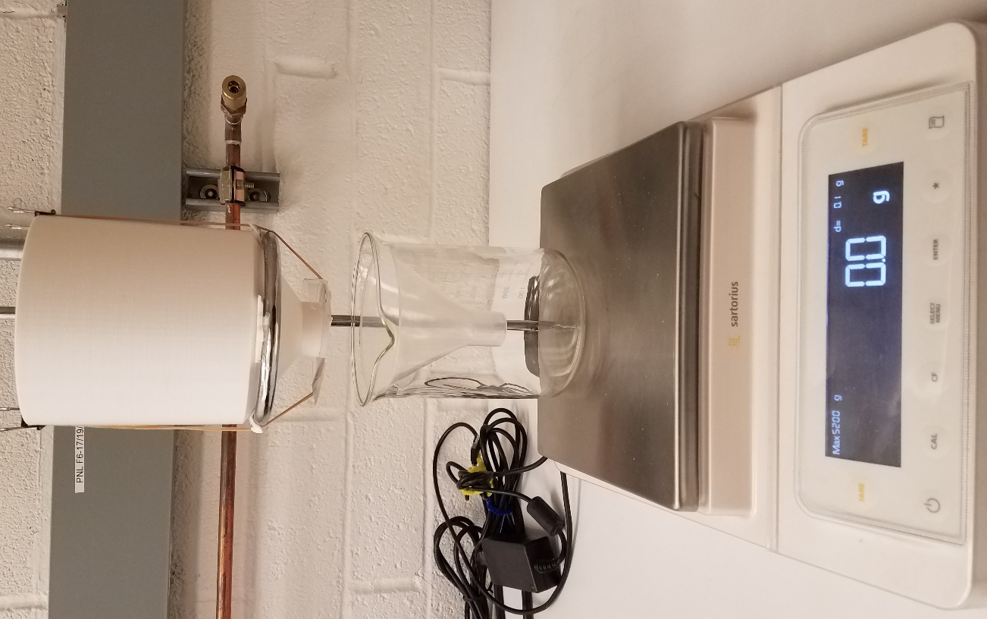
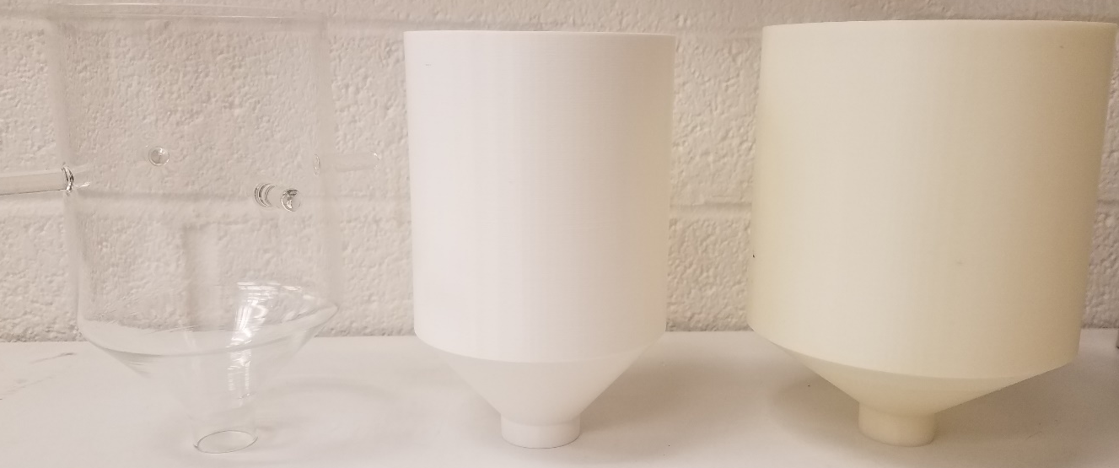

Background section
Knowing how a particle will behave while being discharged from a hopper, will help engineers avoid problems dealing with content uniformity of the discharge, particles adhering to the sides of the hopper, and particle clogging the hoppers outlet, stopping the flow.

